 | Assignment No. 1  Semester: Fall 2026  CS201 – Introduction to Programming |  | Total Marks: 20  Due Date: November 06, 2026
Instructions
Please read the following instructions carefully before submitting the assignment:
It should be clear that your assignment will not get any credit if:

- Assignment is submitted after the due date.
- Submitted assignment does not open or file is corrupt.
- Assignment is copied (From the internet/other students).
- Assignment is submitted in any file format other than .cpp.

Recommended tool to develop the Assignment
- Dev C++

Objectives:
To enable students to understand and practice the concepts of:
- Variables
- Constants
- Data types
- Arithmetic operators
- Conditional statements
- Output statements
- Iterative statements

Assignment Submission Instructions

You must submit only a .cpp file on the assignments interface of CS201 from your LMS account. Assignments submitted in any other format (image, pdf, doc, docx, rar, zip etc) will be given zero marks. So, check your solution file format before submission.

For any query related to the assignment, please contact CS201@vu.edu.pk.

Assignment

Problem Statement
A university IT helpdesk receives support tickets from five campus service desks. Your program must hard-code your own VU Student ID and name. It will then extract five individual digits from your ID, each digit representing the number of support tickets received by one of the five service desks. Assuming each ticket requires a fixed amount of time to resolve, the program will calculate the estimated resolution time for each desk, classify each desk according to its workload, and produce a final overall helpdesk workload report, all derived entirely from your hard-coded ID.
Detailed Requirements
Step 1 – Student Information
Hard-code your full name and VU Student ID. Display both first. No input is allowed.
Step 2 – Digit Extraction
From the 9-digit numeric part of your ID, extract 5 digits using only arithmetic operators (/ and %).
Extract the digits at positions 2nd, 4th, 5th, 6th, and 8th (left to right).
Example: if numeric part is 123456789, the extracted digits are 2, 4, 5, 6, 8.
The use of arrays and string operations are not allowed. Extraction must be done purely through division and modulus arithmetic operations.
Display the 5 extracted digits before proceeding.
Step 3 – Assign Digits to Service Desk
Each extracted digit represents the total number of tickets in a particular service desk.
The five service desks are Network Support, Computer Lab Support, LMS Support, Account Support, and Hardware Support. Assign the five extracted digits to these service desks in the order listed below.

Extracted Digits at position | Service Desk
2nd | Network Support
4th | Computer Lab Support
5th | LMS Support
6th | Account Support
8th | Hardware Support
Step 4 – Calculate the Estimated resolution time measurement
Estimated resolution time = number of tickets × 20 minutes.
For each service desk, display its name, quantity (the assigned digit), and estimated measure.
Step 5 – Workload Classification
Classify each service desk using the following rules:
- 7 or more tickets → HEAVY; 4 to 6 tickets → MODERATE; fewer than 4 tickets → LIGHT.
Display the classification alongside the service desk's information. Use if/else-if or switch.
Step 6 – Summary
Display the number of LIGHT, MODERATE, and HEAVY service desks.
Also display a clear heading and the five service desk records in an organized report.

Expected Output Format:

Your program should display output in a clear and organized manner, similar to the given Sample output:

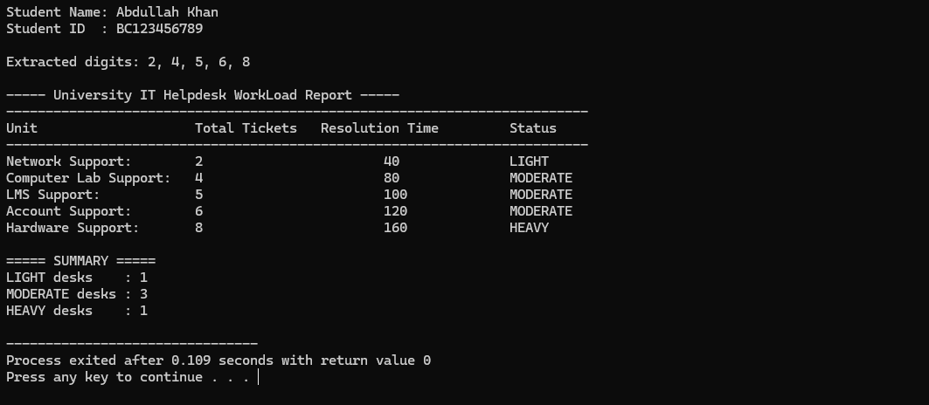

Syllabus:

The syllabus for this assignment includes all topics covered in lecture no. 1 to lecture no. 9.

Note: Remember that printf and scanf are not allowed. if you use these functions in the program, your marks will be deducted.

Best of luck!

